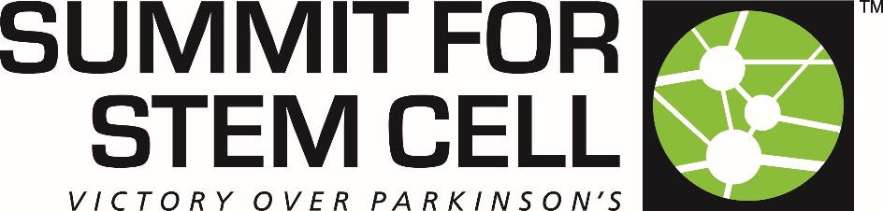

SUMMIT FOR STEM CELL FOUNDATION – OUR STORY: CHAPTER 2
- There are over 1 million Americans struggling with Parkinson’s disease (PD) with over 60,000 new cases diagnosed each year.

- By the time of a PD diagnosis, over 50% of the neurons that make dopamine have already been lost. Earlier detection is not currently possible and no therapy exists to stop further loss of dopamine-producing neurons once a diagnosis has been made.

- More people have Parkinson’s disease than multiple sclerosis (MS), Lou Gehrig’s disease (amyotrophic lateral schlerosis -ALS) and muscular dystrophy (MD) combined…
Advances in modern medicine are allowing people to live longer lives, but few options are available to heal the brain. We believe that cell replacement therapy (regenerative medicine) is the best hope to treat neurological-related and brain-related disorders like PD.
Summit for Stem Cell Foundation’s mission is to support, educate and raise awareness about the development of today’s and tomorrow’s evidence-based regenerative medical therapies focused on Parkinson’s disease and other neurodegenerative conditions. It is our goal to empower patients and their caregivers with the information to elevate their understanding in order to manage their healthcare.
We have a vision of a future with regenerative medicine integrated into mainstream healthcare as a treatment option for persons with Parkinson’s disease and other neurodegenerative conditions.
Summit for Stem Cell Foundation (Summit) is a 501(c)(3) volunteer organization that is dedicated to raising funds to support evidence-based regenerative medical research that will benefit patients with PD and other neurodegenerative conditions through these three main mechanisms:
SUPPORT - Summit supports and/or provides funds for:
- Innovative evidence-based regenerative medical research
- Fellowships & Internships
- Patients in need
- Patient Advocacy
EDUCATION - Summit provides information about evidence-based regenerative
medicine for PD and neurodegenerative conditions through:
- Educational Presentations
- Conferences, Seminars & Events
- Educational Programs
RAISE AWARENESS - Summit is dedicated to elevating public and professional awareness about:
- Evidence-based regenerative medical research
- The autologous dopamine neuron replacement therapy that Summit helped launch and its progress towards FDA-approved clinical trials.
SUMMIT’S HISTORY
Summit was founded in 2011 because of a desire from a group of Parkinson’s patients to fund a stem cell-based therapy. Summit started as a small group of friends raising funds for a cause they believed in and has since grown into a large organization with supporters all over the world. Summit became a 501(c)(3) non-profit organization in 2015 with a dedicated board of diverse professionals. The organization funded and supported the work in Dr. Jeanne Loring’s lab at the Scripps Research Institute, La Jolla, California. This led to the eventual opening of the Summit for Stem Cell Lab to better support the development of an autologous neuron replacement program.
Late 2018, Summit's primary objective was realized. That objective was to enable Dr. Jeanne Loring's and Dr. Andres Bratt-Leal's autologous dopamine neuron replacement therapy for Parkinson's disease​ research project to move from bench to bedside as effectively and as quickly as possible. Summit successfully supported and promoted this brilliant body of science resulting in the founding of a biotechnology company in late 2018. The iPSC-based therapy has since been transferred to the private biotechnology company, Aspen Neuroscience, Inc. Today, the cell-based therapy is now focused on an accelerated path to FDA-approved clinical trials.
Although Summit no longer directly funds the scientific development of the therapy, being a founding partner in Aspen Neuroscience, Summit continues to:
- Monitor the progress of the induced pluripotent stem cell-based (iPSC-based) therapy for PD.
- Provide informational updates.
- Maintain a collaborative relationship with Aspen Neuroscience.
SUMMIT - CHAPTER 2
In 2019, Summit entered Chapter 2. A new board has been formed, once again, with dedicated and diverse professionals. Summit’s new Board of Directors is moving forward with a new Mission and new goals. However, Summit’s dedication and focus remain with the same intensity:
- To improve the lives of people with Parkinson’s and other neurological degenerative conditions.
In Chapter 1 of Summit’s existence, we successfully launched an iPSC-based therapy as a future option to address the symptoms of Parkinson’s disease. But the long-standing questions remain:
- What is the Cause of Parkinson’s disease?
- What is the Cure of Parkinson’s disease?
We are currently dedicated and committed to finding the answers to these “old” questions by funding and supporting innovative and new research.
Your donations are used to support our efforts for the benefit of Parkinson’s patients, their loved ones, and their caregivers in ways such as:
- Innovative and new evidence-based Regenerative Medical Research looking for the Cause and Cure of Parkinson’s disease.
- Microgravity Research to study 3D cellular models of neuroinflammation affects in PD and MS.
- Funding Fellowships and Internships.
- Our Educational Programs
  - About Stem Cells
  - About autologous dopamine neuron replacement therapy for PD.
- Speaking at Patient Support Groups (including travel expenses if over 90 miles away).
- Providing information that is current and vital.
- To empower patients and physicians with information to elevate their understanding in order to manage their care.
- Early detection and prevention.
- Outreach: 7-10 million worldwide have PD. We feel they deserve and need to know about the iPSC-based therapy as a future viable option for treatment.
- Provide assistance and support for those wishing to receive the autologous dopamine neuron replacement therapy for Parkinson’s disease when it becomes available.

We invite you to join and support our efforts towards a Victory Over Parkinson’s and other neurodegenerative conditions with a future where regenerative medicine is a reality in mainstream healthcare for the millions suffering from Parkinson's and other neurodegenerative disorders. ​
Please donate today.
We thank you,

The Board of Directors
Summit for Stem Cell Foundation
www.SummitforStemCell.org

